Brain Games

By Jenna Dunford   
2127324

WSOA3003A 2022  
**Exam Report**

This report and the resulting prototypes discuss the subject of mental health and mental illness. There are no explicit references to the extreme negative consequences of mental disorders, however, if this subject may cause discomfort in the reader, please either proceed with caution or refrain from reading this report. Thank you.

CONTENTS  
1. Introduction  
2. Hypothesis   
3. Prototype 1: Methodology and Process  
4. Prototype 2: Methodology and Process  
5. Reflection  
6. Conclusion  
7. References  
8. Appendix

1. **Introduction**

This report details the construction of two prototypes that illustrate an investigation and finding of an answer to the hypothesis question: How can I use my own mental health experiences and the medications I use to manage them as subject material for attack simulation experiences in a positive light?

The solutions developed are digital and interactive, relying on user input. The scope of the development for the solutions was strictly confined by the requirements set out in the hypothesis question. This report contains a section detailing and breaking down the hypothesis question, providing relevant context, discussing the research and exploration required for the solutions, and discussing how the process and methodology will be discussed. Then, the process and methodology for each prototype will be discussed in detail, this will be followed by a reflection on this assignment, the success of the investigation and suggestions for improvement. Thereafter the report will be concluded.

There is an appendix at the end of the report containing documents and relevant information pertaining to the report.

1. **Hypothesis**
   1. **Hypothesis Question**

**How** can I use **my own mental health experiences** and the **medications I** **use** to manage them as **subject material** for **attack simulation experiences** in a **positive light**?

* 1. **Breakdown and Context of Hypothesis**

The words and phrases that have been made bold in the above hypothesis question will be defined and explained in order to breakdown the hypothesis as well provide necessary context for both the hypothesis and the remainder of the report.

* + 1. **How**

“How” is literally defined as “by what means” [1]. Various solutions using the requirements in the hypothesis should be found, and the means by which these solutions are found should be investigated.

* + 1. **My own mental health experiences**

I am specific here about using “my” in the hypothesis. I am not trying to generalize mental health issues for all persons, the context of these experiences is entirely my own. I define mental health experiences as the way my mental illnesses (mainly anxiety and depression) impact my life, this includes how I manage my mental illnesses with medication.

* + 1. **Medications I use**

I am specific about the usage of the world “I”; I am only exploring medications that I have personally used. The medications that I refer to are used in the treatment and management of mental illnesses. Please refer to the appendix of this report for a full list of the medications I refer to in this prototype.

* + 1. **Subject material (my own mental health experiences and the medications I use to manage them)**

Subject material is the concept that the design of the solutions be based on. The entire design should relate back to the subject material. It may not be possible to ensure that absolutely every faucet of the designs depend on the subject material, but every effort should be made to achieve this, and explanations should be given where not achieved.

* + 1. **Attack Simulation Experiences**

The prototypes developed as solutions may be considered “games”, but the aim is to develop experiences. The solutions should receive user input and produce an output based on the input that aids an overall demonstration of a concept. The concept is an “attack simulation”. I define an attack simulation as the increasing and decreasing of variables representing either health, energy, attack strength, etc. through actions performed by the user or the prototype system.

* + 1. **Positive Light**

Mental illness is not a very “positive” subject to deal with. However, I aim to focus mainly on the role that medications play in my mental health experiences, not necessarily the negative impact that mental illness has on my life. I want the results developed as solutions to be positive in nature. This does not mean that the experiences should be “fun” or “light-hearted”, but the negative consequences of mental illnesses should not be at the forefront of the solutions developed.

* 1. **Research Required for the Hypothesis**

For a solution to be developed as an answer to the hypothesis, much of the research should include self-reflection of my personal experiences with mental illness. Along with this, research should be done on the medications that I use to manage my mental illnesses in order to generate ideas on how to develop systems based on them.

Research should also be done by playing games with battle and attack systems in order to learn about different attack simulation experiences.

The main games played and used as reference and inspiration for the developed solutions were:

**1. Pokémon Legends: Arceus** [2]  
For this game, special attention was given to the Pokémon battling system. The system is turn-based, which is a battle genre that was used for development of one of the systems.   
**2. Undertale** [3]  
Undertale consists of many turn-based combat scenarios, with very creative explorations of the traditional turn-based fighting system.  
**3. Chess** [4]  
Chess is an interesting turn-based fighting experience to explore. Chess does not have traditional variables such as health that can be increased or decreased, but there are the pieces themselves, which can be considered variables that are lessened throughout the progression of a game. Chess was not used as a huge inspiration for the systems developed but is an interesting model to investigate for a turn-based fighting experience.  
**4. Breath of the Wild** [5]  
Breath of the Wild does not contain any turn-based combat, and the combat systems are complex, but is interesting to explore because at its base level, it is still simple the increasing and decreasing of variables that determine the outcome of different attack encounters.

* 1. **Exploration Required for the Hypothesis**

For the hypothesis question to be answered successfully, more than one medium for exploration should be utilized. For this assignment, two prototypes were developed in two different mediums in order to explore the effectiveness of each.

Turn-based combat was explored. The other aspect of exploration was done using Pokémon Attack Strength generators [6] as inspiration. These two explorations are complementary, as attack strength generators can be used to implement a full turn-based combat experience. However, in order to fully explore the hypothesis question, both explorations are separate in how they deal with the subject material.

* 1. **Introducing the Process and Methodology**

The following two sections of this report will detail the process and methodology for the two prototypes that were developed as solutions to the hypothesis questions.

The prototypes will be described, with thorough instructions on how to play or interact with them, the process and methodology will be discussed in detail. The process will refer to the initial design and development of the prototype with reference to the hypothesis, the methodology will discuss the implementation of the design into the prototype itself, also with specific reference to the hypothesis.

Specific design elements will be discussed for each prototype, with reference to the hypothesis question. Where required, discussion of the mathematical equations used will be explored. Testing and playtester data will also be shown and discussed.

As the prototypes are considered solutions to the question given by the hypothesis, their effectiveness and success will be evaluated by how well they answer the initial hypothesis question.

1. **Prototype 1: Process and Methodology**
   1. **Description of Prototype 1**

Describe what the build for prototype actually is, discuss why it is in the context of the hypothesis.

Discuss the game itself and instructions on how to play it

* 1. **Chosen Process for Prototype 1**

Describe the process for the development and design of prototype 1, refer back to the hypothesis for the process

* 1. **Methodology for Prototype 1**

Discuss how the design was implemented for prototype 1. Refer to commits from GitHub repository. Discuss script design and code.

* 1. **Elements of Visual Design for Prototype 1**

Discuss the visual design of prototype 1 – discuss decisions made based on hypothesis question

* 1. **Elements of System Design for Prototype 1**

Discuss the system design of prototype 1 – discuss decisions made based on hypothesis question

* 1. **Mathematical Considerations**

Discuss how equations were implemented. Talk about exponential function used for health and energy increases.

* 1. **Playtest Process and Significance**

Talk about how the game had to be played through in order to balance out different mechanics

1. **Prototype 2: Process and Methodology**
   1. **Description of Prototype 2**

Discuss what the build for prototype 2 actually is and why and how it relates to the hypothesis question, as well as inspiration and reference used for it.

Discuss how to use prototype 2, instructions, examples of outputs.

* 1. **Chosen Process for Prototype 2**

Discuss process used for developing design of prototype 2 in relation to the hypothesis question.

* 1. **Methodology for Prototype 2**

Discuss methodology used for prototype 2, how system was implemented. Relate back to hypothesis.

* 1. **Elements of System Design for Prototype 2**

Discuss the system design for prototype 2, discussion of functions and choices of user input and output display.

* 1. **Discussion of Prototype 2 Playtester Data**

Show examples of the playtester data collected and how it either strengthens or weakens the hypothesis question. Discuss suggestions for improvements.

1. **Reflection**

Insight into the construction – why did I choose to make two prototypes? Would one prototype have been as effective? Should I have made more prototypes? Did the development relate to the hypothesis question? What would I have changed in the construction? What technical and design lessons did I learn from this process?

, What was learned. Was it effective? How can it be improved or extended?

Were the prototypes developed effective in answering the hypothesis question?

How could prototype 1 be improved or extended to better answer the hypothesis question?

How could prototype 2 be improved or extended to better answer the hypothesis question?

Finally, what was the answer to the given hypothesis question? Is it what I, the designer had hoped for?

1. **Conclusion**

Concluding the report

1. **References**

|  |  |
| --- | --- |
| [1] | Collins Dictionary, "Definition of 'how'," 2022. [Online]. Available: https://www.collinsdictionary.com/dictionary/english/how. [Accessed 27 June 2022]. |
| [2] | Nintendo, "Pokemon Legends Arceus," Nintendo, 2022. [Online]. Available: https://legends.pokemon.com/en-us/. [Accessed 28 June 2022]. |
| [3] | T. Fox, "Undertale," 2015. |
| [4] | Wikipedia, "Chess," 14 June 2022. [Online]. Available: https://en.wikipedia.org/wiki/Chess. [Accessed 28 June 2022]. |
| [5] | Nintendo Entertainment Planning & Development, "The Legend of Zelda: Breath of the Wild," Nintendo, 2017. |
| [6] | psypoke, "POKEMON TOOLS - DAMAGE CALCULATOR," 2022. [Online]. Available: http://www.psypokes.com/dex/damage.php. [Accessed 28 June 2022]. |
| [7] | S. Entringer, "Methylphenidate," 28 October 2021. [Online]. Available: https://www.drugs.com/methylphenidate.html#:~:text=Methylphenidate%20is%20a%20central%20nervous,(ADHD)%2C%20and%20narcolepsy.. [Accessed 28 June 2022]. |
| [8] | C. Multum.], "Clobazam," 19 October 2021. [Online]. Available: https://www.drugs.com/mtm/clobazam.html. [Accessed 28 June 2022]. |
| [9] | Medically Reviewed by Drugs.com, "Selective serotonin reuptake inhibitors (SSRIs)," 7 September 2021. [Online]. Available: https://www.drugs.com/mca/selective-serotonin-reuptake-inhibitors-ssris#ssris-approved-to-treat-depression. [Accessed 28 June 2022]. |
| [10] | Drugs.com, "Non-cardioselective beta blockers," 2022. [Online]. Available: https://www.drugs.com/drug-class/non-cardioselective-beta-blockers.html. [Accessed 28 June 2022]. |

1. **Appendix**
   1. **List of Medications Referred in Assignment**

**MEDICATIONS REFERRED TO IN THIS ASSIGNMENT**

**METHYLPHENIDATE** [7]

Methylphenidate is a stimulant medication that increases activity in the body’s nervous system. It is commonly used to treat ADHD; however, it can also be used to treat the narcolepsy that may occur as a result of mental disorders like depression.

Methylphenidate also goes by the names Ritalin and Concerta, it comes in immediate and slow-release forms. Depression may cause people to become tired and unfocused for long periods of time, methylphenidate combats this by increasing energy and enhancing concentration.

Methylphenidate causes an increased heart rate and elevated awareness – due to this, persons taking methylphenidate may experience heightened levels of anxiety.

**CLOBAZAM/URBANOL** [8]

Clobazam, or Urbanol, is a sedative that can be used to treat seizures. The class of medication is called ‘benzodiazepines.’ Clobazam can also be used to treat anxiety disorder and panic attacks. It can also be used to help with sleeplessness when taken at night.

Clobazam is described as a short-term relief treatment for anxiety, it has a high chance of becoming addictive with constant use. Clobazam works by reducing brain activity, allowing the body to become calm when in a state of nervousness or anxiety.

Clobazam is not a long-term solution for anxiety disorder due to its addictive nature, but it is extremely effective for short-term relief.

**SELECTIVE SEROTONIN REABSORPTION INHIBITORS** [9]

Selective Serotonin Reabsorption Inhibitors (SSRIs) are a class of medications used for the long-term treatment and management of disorders such as anxiety and depression.

SSRIs work by preventing the serotonin chemicals in the brain from being reabsorbed into neurons. It is believed that serotonin has a large effect on mood and general emotional states. Less serotonin may lead to negative mental states.

When a person is suffering from depression or anxiety, the serotonin receptors in the brain may not work as well, and so not as much serotonin is utilized, this leaves serotonin chemicals unused that become reabsorbed into the brain for other purposes. When the serotonin receptors become active again, there is not a sufficient supply of serotonin to provide relief to the brain. This is the working theory for SSRIs, as SSRIs prevent the reabsorption of the serotonin, allowing the balance of serotonin the brain to be restored.

SSRIs may take as long as six weeks to become effective in patients, so patients may still suffer from depression or anxiety during the initial treatment phase. In some cases, the use of SSRIs can cause greater depression and anxiety, including suicidal tendencies, due to this persons using SSRIs need to be closely monitored by their medical practitioners.

SSRIs are used in the medications Lexapro (Escitalopram), Sertraline (Zoloft), and others.

SSRIs are not addictive and can be used over long periods of time. Stopping usage of SSRIs may require slowly weening the patient off of the medication to avoid withdrawal symptoms.

**BETA BLOCKERS** [10]

Beta blockers (beta-adrenergic blocking agents) are medications that block the effects of adrenaline on the body. Beta blockers allow the heart to beat more slowly, lower blood pressure, and can be used to successfully manage the effects of anxiety disorder.

Beta blockers, when used for the treatment of anxiety, are not commonly used consistently over long periods of time, they are mainly used when the need arises for them. This could be during a panic attack, extreme anxiety episode, or when the patient knows that an extremely stressful or traumatic situation is about to occur. An example of a beta blocker medication is Acebutolol.

* 1. **Instructions for Prototype 1**

**HOW TO LAUNCH AND PLAY PROTOTYPE 1**

Prototype 1 will be contained in the folder labelled: “WSOA3003A PROTOTYPE 1 EXAM BUILD”.

Prototype 1 is an executable Unity build file.

Upon launching the game, the introduction scene will be displayed with instructions for playing the game. For safety, the instructions will be listed here as well. In the introduction scene the user must click the “Play Game” button in order to proceed to the game.

Playing the Game:

1. When it is the player’s turn, indicated by the turn text in the UI, the user must select an attack from the list of attacks.
2. Pressing “E” on the keyboard will bring up information about the selected attack.
3. After choosing an attack, the user must press the “Attack Button” in order to attack the enemy
4. After attacking, the enemy will respond with an attack.
5. The user must continue attacking the enemy and taking note of the enemy’s attacks until either the enemy’s or player’s health is at zero.
6. Once the enemy or player’s health is at zero, the end scene will load, announcing whether the player or the enemy has won the game.
   1. **Instructions for Prototype 2**

**HOW TO LAUNCH AND USE PROTOTYPE 2**

Prototype 2 is a webpage hosted on the following link:

<https://jennadunford.github.io/WSOA3003-Exam/>

The webpage will have drop-down lists for: “Medimons” and “Brain Monsters”.

Once a Medimon and Brain Monster has been selected, drop-down lists will become available with the attacks for the selected Medimon and Brain Monster.

After an attack has been selected for each, pressing the “Attack” button on the webpage will generate results for the attack parameters that were set by the user. This includes a description of each attack, the hit chance for the attack, the calculated strength of the attack, the success of the attack, and whether or not the attack would have hit its target.

This prototype is a simple attack generator that can be used to test out a number of different Medimon and Brain Monster attack scenarios.

As you scroll down on the webpage, explanations are given about the system of the prototype, as well as descriptions for the Medimon’s and Brain Monsters and what they represent.

If the given link does not work for the second prototype, the html, CSS, JavaScript, and image files are contained within the folder labelled “WSOA3003A PROTOTYPE 2 EXAM FILES”. The webpage should be able to be opened in any browser by opening the “index.html” file.

* 1. **Prototype 2 Playtester Responses**

**PLAYTESTER RESPONSES FOR PROTOTYPE 2**

*Grammatical and spelling edits have been made to responses given by playtesters

**QUESTION 1: What are your general thoughts on the prototype?**

PLAYTESTER1 RESPONSE: “The concept is interesting. I don't really understand how the attack strength values are determined. I can see that if I attack with 95% success chance and the enemy attacks with 55%, I'm probably gonna win, but I don't see how the strength values are determined from the percentages.”

PLAYTESTER2 RESPONSE: “It was interesting to read everything, but I know a lot of people skim over things when it comes to reading in games”

PLAYTESTER3 RESPONSE: “Very interesting take on the subject chosen and works well with the genre of fantasy.”

PLAYTESTER4 RESPONSE: “Having gone through some of the mentioned mental struggles in your game I found it to be quite nice to actually see something so negative be turned into a game that you can simulate beating depression for example. I think the idea is really cool and if you were to make it a complete game in the future it could be a really cool game to put on itch and maybe make it to steam or epic.”

**QUESTION 2: Do you think that the representations of mental illness were depicted well?**

PLAYTESTER1 RESPONSE: YES

PLAYTESTER2 RESPONSE: YES

PLAYTESTER3 RESPONSE: YES

PLAYTESTER4 RESPONSE: YES

**QUESTION 3: Were the descriptions of the attacks entertaining/interesting to read?**

PLAYTESTER1 RESPONSE: YES

PLAYTESTER2 RESPONSE: YES

PLAYTESTER3 RESPONSE: YES

PLAYTESTER4 RESPONSE YES

**QUESTION 4: What suggestions do you have for this attack simulator prototype, if any?**

PLAYTESTER1 RESPONSE: “Maybe some pictures to help show player and enemy characters.

“I know you included a description of the mental illnesses and medications at the bottom, but it would be nice to see some stats before you play. Like how stats are shown on [Pokémon] and [Yu Gi Oh] cards, so that I can determine what the best move is, [because] it [kind of] feels like I don't have anything informative to base my decisions on.”

PLAYTESTER2 RESPONSE: “Maybe a visual aid or visual representations as it is very wordy”

PLAYTESTER3 RESPONSE: “Maybe creating fantasy art for the Medimons and brain monsters. But this is not a major addition that's necessary.”

PLAYTESTER4 RESPONSE: “The only suggestion I can think of would be to maybe make it almost like a deck building game but that would be if you were to work on the game further than the exam. You could almost make it a deck builder where you start out [with] basic cards and then progress though "dungeons" defeating different types of mental illnesses. But as I say that would be something to maybe work towards after the exam submission. As of now I really like the game and its idea.”

**QUESTION 5: Would you be interested in a full-fledged game being created from this prototype?**

PLAYTESTER1 RESPONSE: YES

PLAYTESTER2 RESPONSE: YES

PLAYTESTER3 RESPONSE: YES

PLAYTESTER4 RESPONSE: YES

**QUESTION 6: Do you think fantasy was a good genre to use for the theme of this prototype? Do you think another genre would have been better?**

PLAYTESTER1 RESPONSE: “Yeah, fantasy works great. Sci fi could be cool too but I like the fantasy theme.”

PLAYTESTER2 RESPONSE: “I liked the fantasy element, but I think often adventure genres can be quite good in portraying mental health”

PLAYTESTER3 RESPONSE: “I think the fantasy genre blended well with the subject.”

PLAYTESTER4 RESPONSE: “I enjoy the fantasy genre and I think this was a great design decision as mental illnesses cannot be portrayed with things from our normal world and by making it fantasy you can create what you think it would look like. I would not change to a different genre. I think you made a really good design decision by making it fantasy.”

**QUESTION 7: Was testing the prototype a fun experience?**

PLAYTESTER1 RESPONSE: “Yes and no. It was fun to read the descriptions and stuff, but there was also a lot to read (but this might just be the mobile viewport making it look like more text than there actually [was])”

PLAYTESTER2 RESPONSE: YES

PLAYTESTER3 RESPONSE: YES

PLAYTESTER4 RESPONSE: YES

**Acknowledgements:**

Thank you so much to the wonderful people who playtested this prototype:  
| Suvanya Misra | Dylan Baker | Shen Reddy | Bhaveer Hargovind |  
(Names are not listed in the order of the playtesters)

* 1. **Prototype 1 Annotated User Interface**

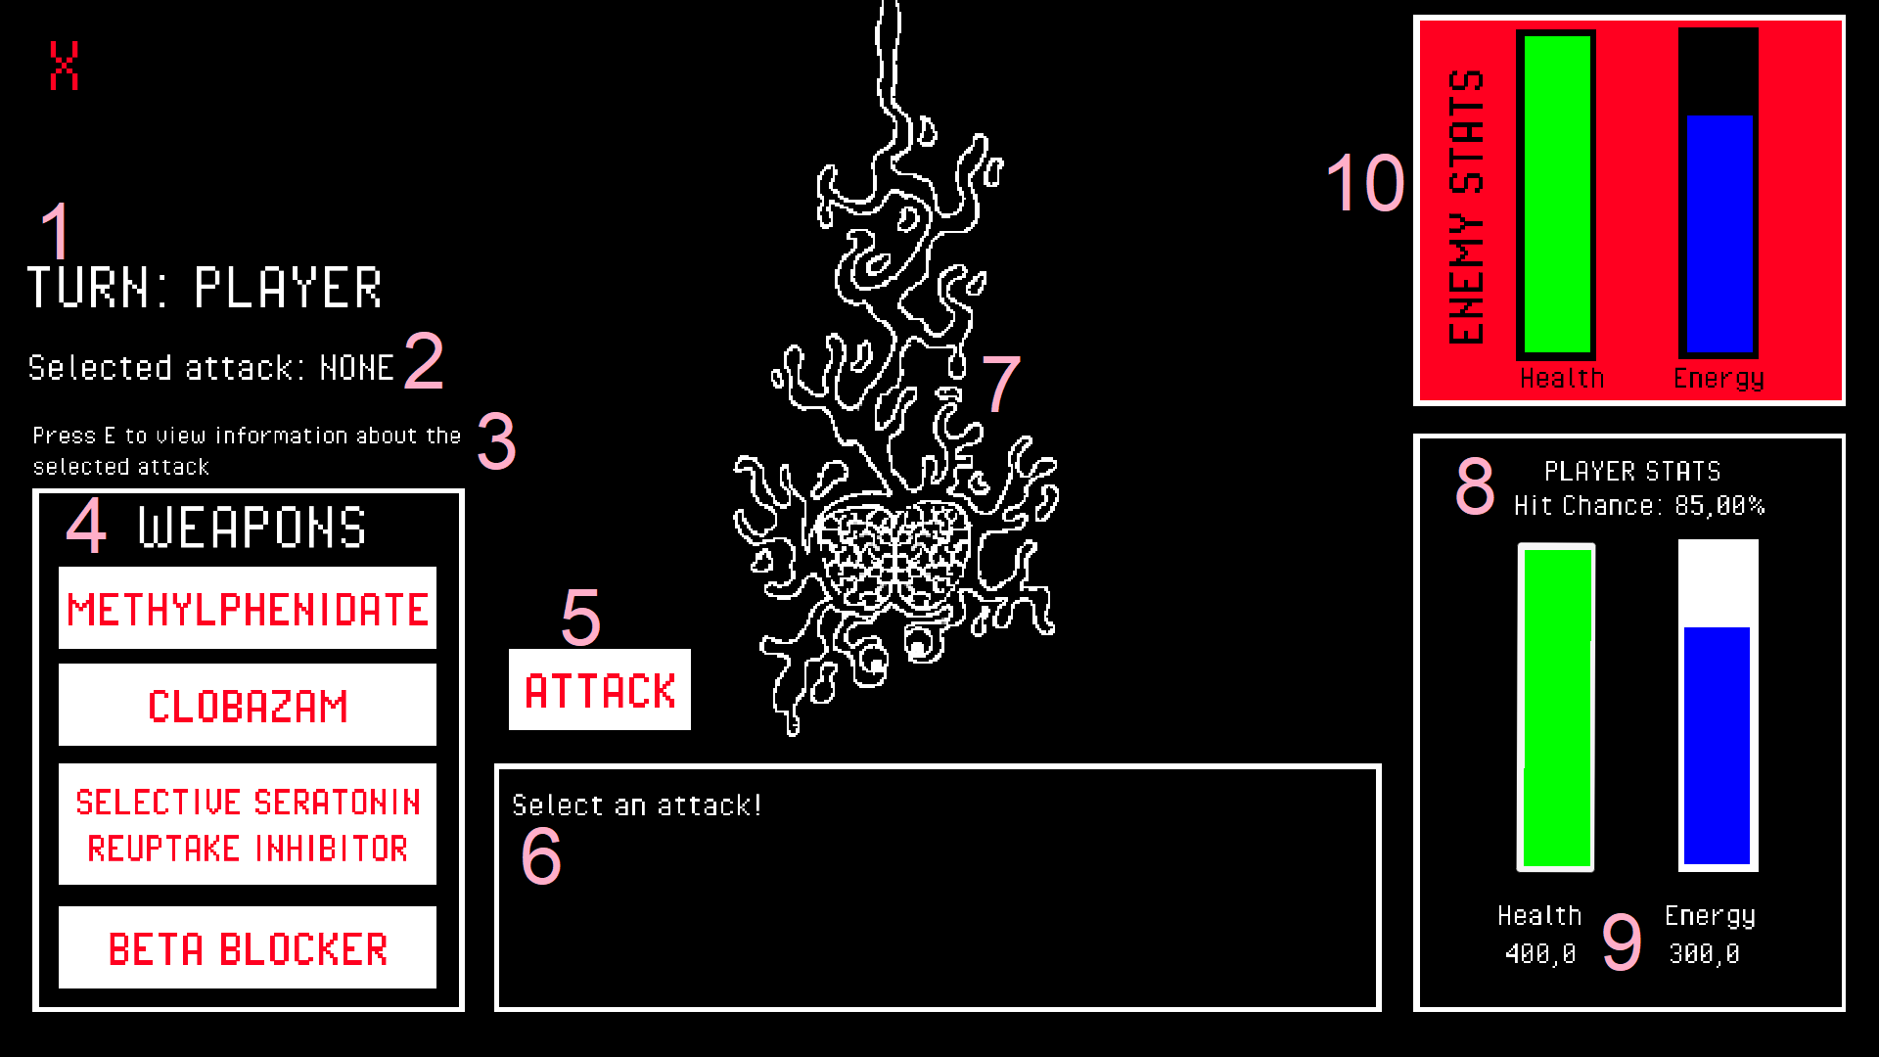**ANNOTATED USER INTERFACE FOR PROTOTYPE 1**

The above image shows the user interface in Prototype 1. Various aspects of the user interface are labelled with numbers in pink from 1 to 10. Each of these aspects will be discussed in this section.

1. The Turn Text

The turn text is large, but off to the left edge of the screen, this is so that it does not draw too much attention to itself. The turn text exists in order to inform the player of the current state of the game. The player knows that it is their turn if the turn text indicates it to them. The turn text color changes from white to red when it is the enemy’s turn to give feedback to the player that danger is occurring, it is the enemy’s turn.

1. Selected Attack Text

The selected attack text exists to indicate to the player which attack they have currently selected. This allows the player to check that they have selected their desired attack correctly before pressing the attack button (by annotated number 5). This also shows the player which information will be brought up upon viewing the attack information.

1. Viewing Attack Information Instructions

This text informs the player that pressing “E” will show the player information about the attacks. This text exists because it is important for the player to take note of the purpose of each attack.

1. Weapons List

The weapons list is large, as are the buttons for selecting the weapons, as they are an important part of the gameplay and therefore should take up a significant part of the user interface. The text for the attacks is red, showing that they pose a danger to the enemy.

1. Attack Button

The attack button is large and near the center of the screen, this is because attacking is an important part of the gameplay and should be near the center of the player’s attention. The attack button is near the depiction of the enemy (annotated number 7) in order to indicate that the attack affects the enemy. The attack button text is in red to indicate that the attack button will endanger the enemy.

1. Event text box

The event text box contains text that indicates what is happening within the game. It tells the player what it attacked with and the effects of the attack, it tells the player when the enemy is about to attack, it tells the player whether they or the enemy missed an attack, and it indicates to the player when they should be selecting an attack. The event text box is in the center of the screen because it is important for the player to know what is currently happening within the game.

1. Enemy Animation

The enemy is drawn as a goopy, disgusting looking brain monster to communicate to the player that it is dangerous, gross, and should be defeated. The enemy is animated to look as though it is dripping with slime and writhing about during the gameplay. The enemy is large on the screen, because it is the main focus for the player – it is the target for the player’s attacks, and it is what the player is trying to defeat.

1. Player hit chance text

The player hit chance text is small but exists in the UI so that the player can view their attack chance percentage to allow them to make informed decisions about their attacks. The attack chance is small because it should not impact the player’s decisions too much, however it is still useful information to have on hand.

1. Player Health and Energy Bars

The player health and energy bars are large because they are important for the player to take note of during gameplay. The health and energy bars have the value of the health and energy underneath them so that the player has more detailed information on the level of their health and energy. The bars are vertical to give the appearance of the health and energy falling down or filling up during gameplay. When the health or energy bar value goes below 50%, the color of the bar changes to red in order to warn the player that they need to take note of their health or energy and perform attacks in order to increase the values.

1. Enemy Statistic Holder, Health, and Energy Bars

The enemy statistic holder is red, this is to indicate that it belongs to the enemy – the red color makes it abruptly different from the player’s statistic holder. The enemy’s health and energy bars do not show the specific values – this information is withheld from the player to invoke a small amount of confusion from the player about the specific level that the enemy is at. However, the visual information from the health and energy bars going up and down is still there. The enemy’s health and energy bar colors also change to red once they are below 50% - this is to show the player that the enemy is now in danger, and they can use attacks that take advantage of the enemy’s low health and energy.

* 1. **Prototype 2 User Interface**

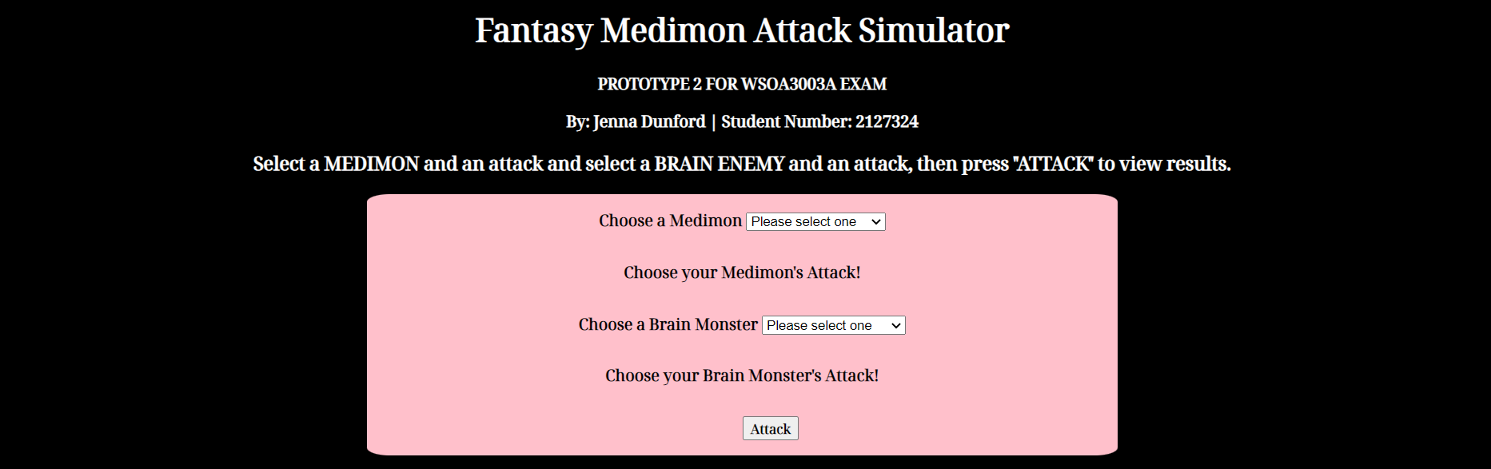**USER INTERFACE FOR PROTOTYPE 2**

The above image shows the user interface created for prototype 2.

The user interface is very simple, containing instructions and dropdown lists for the user to select from.

The simplicity of this user interface is due to the fact that it is only a generator to display different attack combinations and results, this is not a gameplay experience, and so only simple and straightforward user input methods were necessary for this user interface.

* 1. System Design Documents and Flowcharts for Prototype 1

**SYSTEM DESIGN AND FLOWCHART DIAGRAMS FOR PROTOTYPE 1**

The following block diagram shows the events that occur within the prototype 1 system:

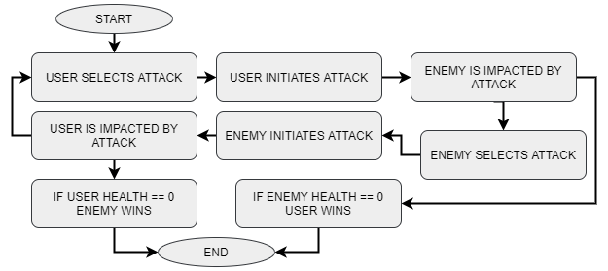

Each event will be explained using annotated flow diagrams or lists and descriptions of the functions, with explanations on how they relate and answer the hypothesis question.

**USER ATTACK SELECTION**

Table of functions for User Attack Selection

|  |  |  |  |
| --- | --- | --- | --- |
| **Function Name** | **Location** | **Function Description** | **Relation to Hypothesis Question** |
| selectMethyl() | selectButtons.cs | Sets the integer “select” to 1.  Sets the selected attack text in the UI to show that Methylphenidate is selected | Selecting methylphenidate (described in Appendix section 8.1) to attack the representation of mental illness solidifies the usage of medications to manage mental illness as an integral part of the **subject material** of prototype 1.  The idea of medication being used as weapon to defeat mental illness also relates to the “**positive light**” requirement of the hypothesis. |
| selectClob() | selectButtons.cs | Sets the integer “select” to 2.  Sets the selected attack text in the UI to show that Clobazam is selected. | Selecting Clobazam (described in Appendix section 8.1) to defend against the representation of mental illness solidifies the usage of medications to manage mental illness as an integral part of the **subject material** of prototype 1.  The idea of being able to defend yourself against mental illness using an attack also relates to the “**positive light**” requirement of the hypothesis. |
| selectSSRI() | selectButtons.cs | Sets the integer “select” to 3.  Sets the selected attack text in the UI to show that SSRIs are selected. | Selecting SSRIs (described in Appendix section 8.1) to fight against the representation of mental illness solidifies the usage of medications to manage mental illness as an integral part of the **subject material** of prototype 1.  The idea of being able to attack mental illness relates to the “**positive light**” requirement of the hypothesis. |
| selectBeta() | selectButtons.cs | Sets the integer “select” to 4. Sets the selected attack text in the UI to show Beta Blockers are selected. | Selecting Beta Blockers (described in Appendix section 8.1) to defend against the representation of mental illness solidifies the usage of medications to manage mental illness as an integral part of the **subject material** of prototype 1.  The idea of being able to defend yourself against mental illness using an attack also relates to the “**positive light**” requirement of the hypothesis. |
| selectPanel() | selectButtons.cs | The select panel is brought up when the player presses E and the integer “select” is set to a number not equal to 0.  The select panel updates each time depending on the value “select” to show information about each of the attacks. | The select panel and updating of its contents to display information about the attacks gives the user insight into the usages of each medication. This strengthens the **subject material** requirement of the hypothesis. The descriptions of the attacks are represented as weapons to use against an enemy, adding **positivity** to the **subject material** by stating that mental illness can be defeated with the usage and help of medications, which can be used as weapons. |

The above table should provide appropriate insight into the workings of the user attack selection part of the prototype 1 system design, also providing explanations on how each function was designed with answering the hypothesis question* in mind.